Given a binary tree, return the sum of values of its deepest leaves.

**Example 1:**

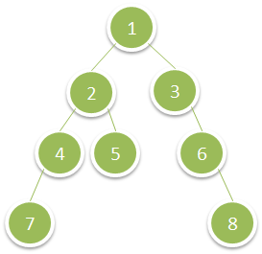

**Input:** root = [1,2,3,4,5,null,6,7,null,null,null,null,8]

**Output:** 15

**Constraints:**

* The number of nodes in the tree is between 1 and 10^4.
* The value of nodes is between 1 and 100.